**Lab Tutorial**

**Class 7**

**Lab 2: Basic Programming (String, Array)**

1. Identify the index numbers and insert element in this 1D array. Please fill the boxs with correct text.

?

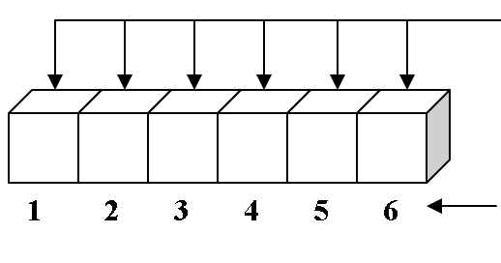

?

1. Question-Answer: Fill the box

?

?

?

String employeeName = “Sharif Chowdhury”;

String emailAdress = “sharif234@gmail.com”;

String Adress = “H-23,Gulshan-2,Gulshan,Dhaka”;

1. Relate and Fill the box:



?



